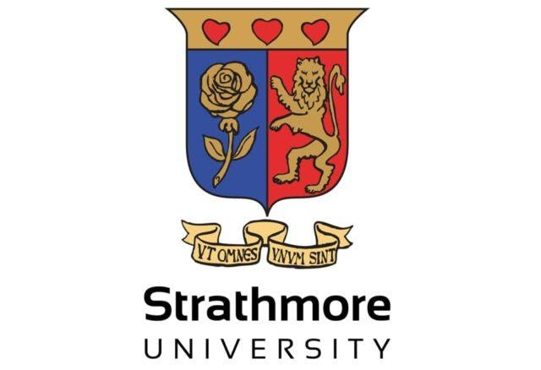
KARATE TITANS MARCH 2025 JOINT TRAINING ANALYSIS
Report period: March 2025
Sensei: Joshua Oude
Captains: Michelle Okero, Edward Mwongela
Introduction
On the 28th of this month, we had the opportunity of hosting Sensei Keelan Gannon from Hombu Dojo in Dublin, Ireland within Strathmore university’s halls for a joint training session with players from multiple universities being in attendance.
On the 29th and 30th, we attended joint training sessions led by him in Parklands Sports club; a different setting that offers a wider perspective in training due to a larger number of higher ranking seniors.
This report offers an analysis as well as a sneak peak into what the joint training offered our students.
Activities
Training included:
- Kihon basics:
- stances – kokutsu dachi (back stance), zenkutsu dachi (front stance), fudo dachi (immovable stance), kiba dachi (horse riding stance).
- Punching and blocking mechanics of the body – what motions the body are made for and can be utilised in the techniques without severely affecting a karateka in the long run.
- Movement and joint mechanics of the body(Ashi sabaki) – how to efficiently and effectively use certain muscle groups when performing certain techniques, such as inner thigh muscles contracting for explosiveness and control. Mostly in zenkutsu dachi and kiba dachi.
- Body weight shifting and support – how to power your techniques using your body weight without losing form and structure.
- Kicking mechanics – keage(side snap kick) and kikomi(side thrust kick)
- Tournament sparring techniques:
- How to use lowering of your centre of gravity to your advantage in the ring
- Speed and power applications in techniques via various dynamic exercises.

- Kata knowledge and improvements:
- Nijushiho(24 steps): an advanced level kata with 21 flowing moves in a specific tempo
- Sochin (Tranquil force): an advanced level kata with 41 moves entailing an intricate balance between fast powerful techniques, and slow and steady techniques
- Bunkai:
Worked on the practical application of Kata in self-defence as well as getting a deeper understanding of the underlying techniques in the movements.

Comments
- Joint workshop trainings have improved standardization of senior katas to a more international level and are consistently improving our student’s skillsets in an all rounded manner
- There has been more exposure of members due to interactions with senior karatekas and national team players with the aim of long term benefits

Upcoming events
- Grading to higher ranks.
Short term goals for the upcoming months
- Preparation of the new members for tournament participation
- Bringing students coming back from long holiday up to speed
- Deepening and enhancement of overall karate levels and knowledge.
- Perfection of the freshly learnt kata
- Improvement of body flexibility and power in senior level karatekas.

